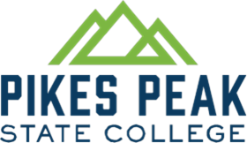
Center for Healthcare Education and Simulation
1850 Cypress Semi Drive
Colorado Springs, CO 80921

Medical Receptionist & Medical Coding Specialist Programs:
Program Learning Outcomes (PLO):

- Identify and describe body system structures and/or, disorders and/or diseases.
- Discuss legal and/or ethical issues as applicable to medical practices.
- Demonstrate effective communication skills.
- Perform medical administrative and/or financial tasks.
- Prepare competent entry-level medical office personnel in the cognitive (knowledge), psychomotor (skills), and affective (behavior) learning domains.

