STUDENT INSTRUCTIONS FOR EPIC TRAINING

* Call Centura Health IT Service Center at 719-776-4200 to obtain password. They will confirm your ID/user name (your instructor was sent your user name and may have sent to you) and assist with password.
* Go to <https://centurahub.centura.org> and log-in using your ID and password
* It is possible that Microsoft may ask you to input your Centura Microsoft email to check credentials before you access applications. If this is the case, here is how you will find out what your Centura email is
  + Once in CenturaHub with your user/password, go to top right where your initials are, pull down menu, look at your profile, and there is their email.

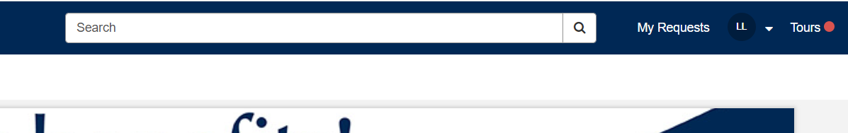

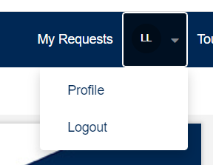

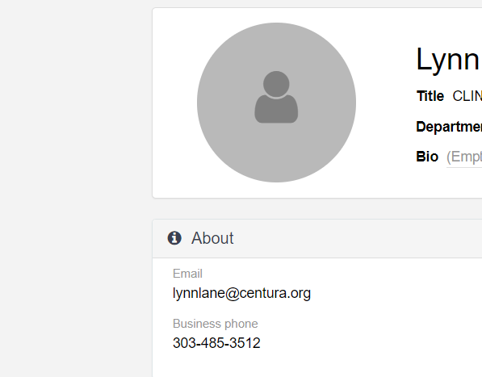

* Use this email if requested to get access to applications
* Go back to home page of CenturaHub. Scroll down Popular Applications
* Click on My Applications and Links
* From Apps search for LEARN/ACADEMY
* Choose the first drop-down option ACADEMY Non-Employee Self Training
* Choose [**Click Here to Continue to Web-Based Training (Academy)**](https://www20.myvirtualworkplace.org/healthstream/healthstreamNonCen.html)
* Complete the training modules (ClinDoc for Inpatient) or (ASAP for ED)
* Print a copy of the EUPA certificate and upload it on to My Clinical Exchange

Note: all of your required learning is on-line, no other classes are required.

Please see some additional screen shots below that may be helpful.

Log into Centura Hub with your current username and password

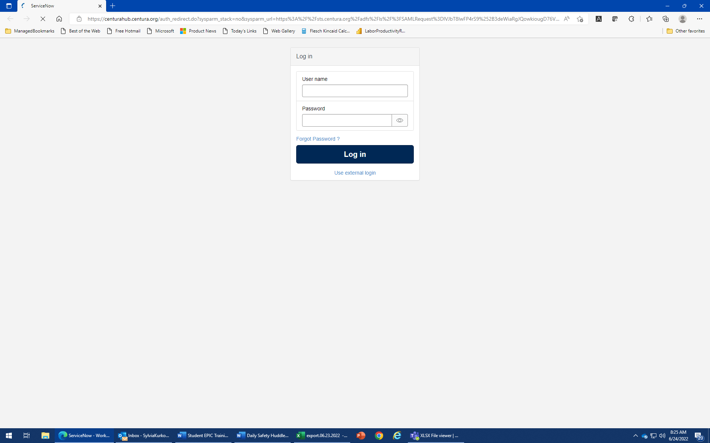

Scroll down to **Popular Applications**

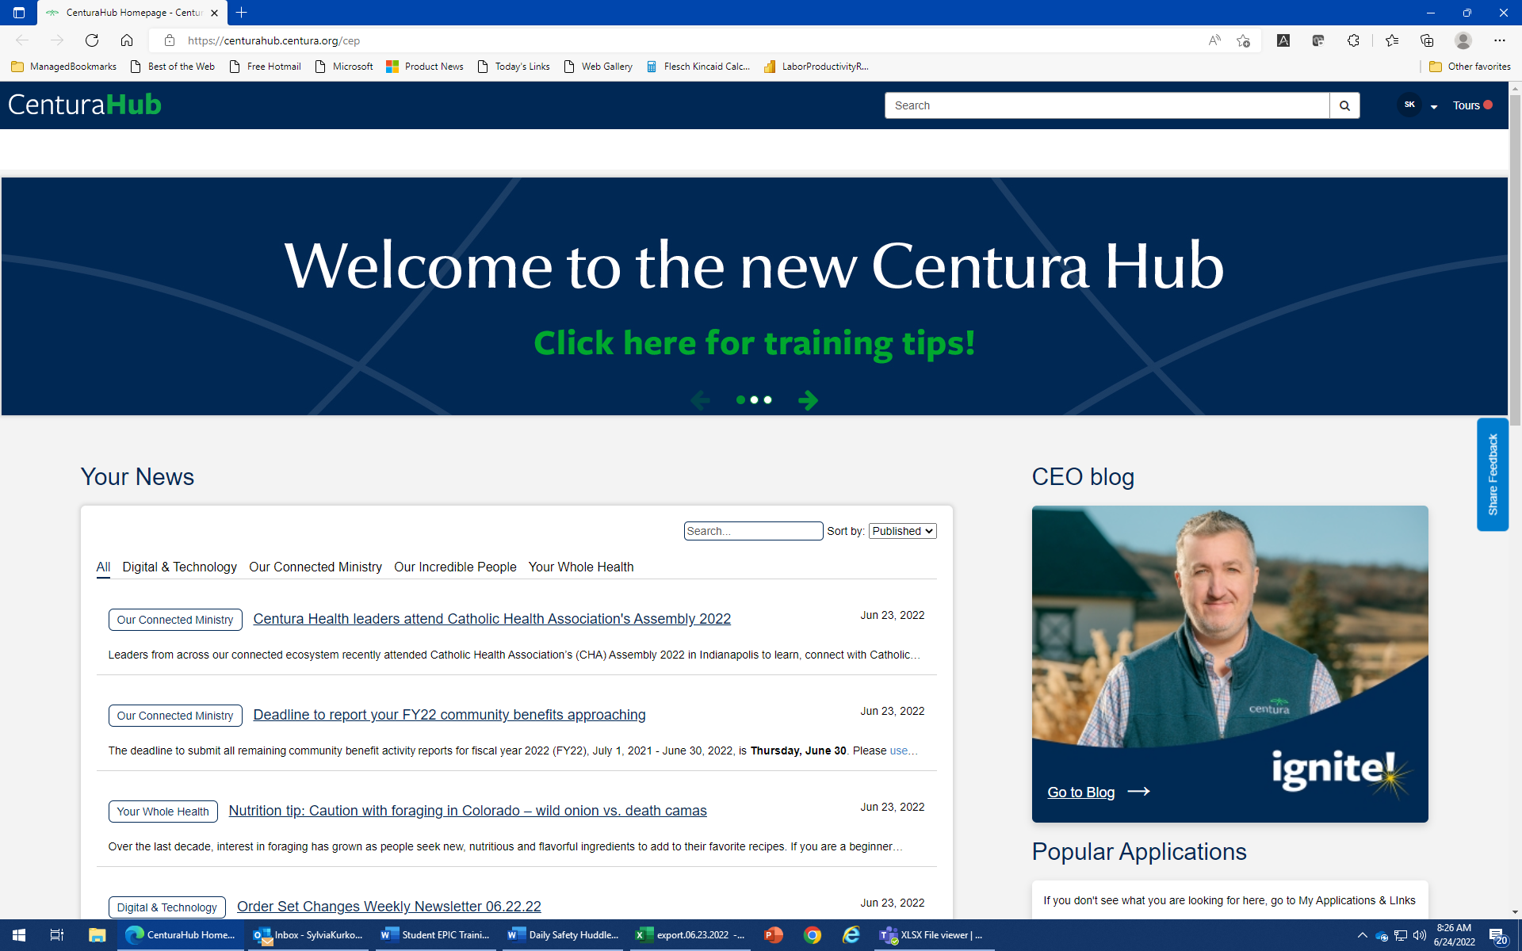

Select **My Applications and Links**

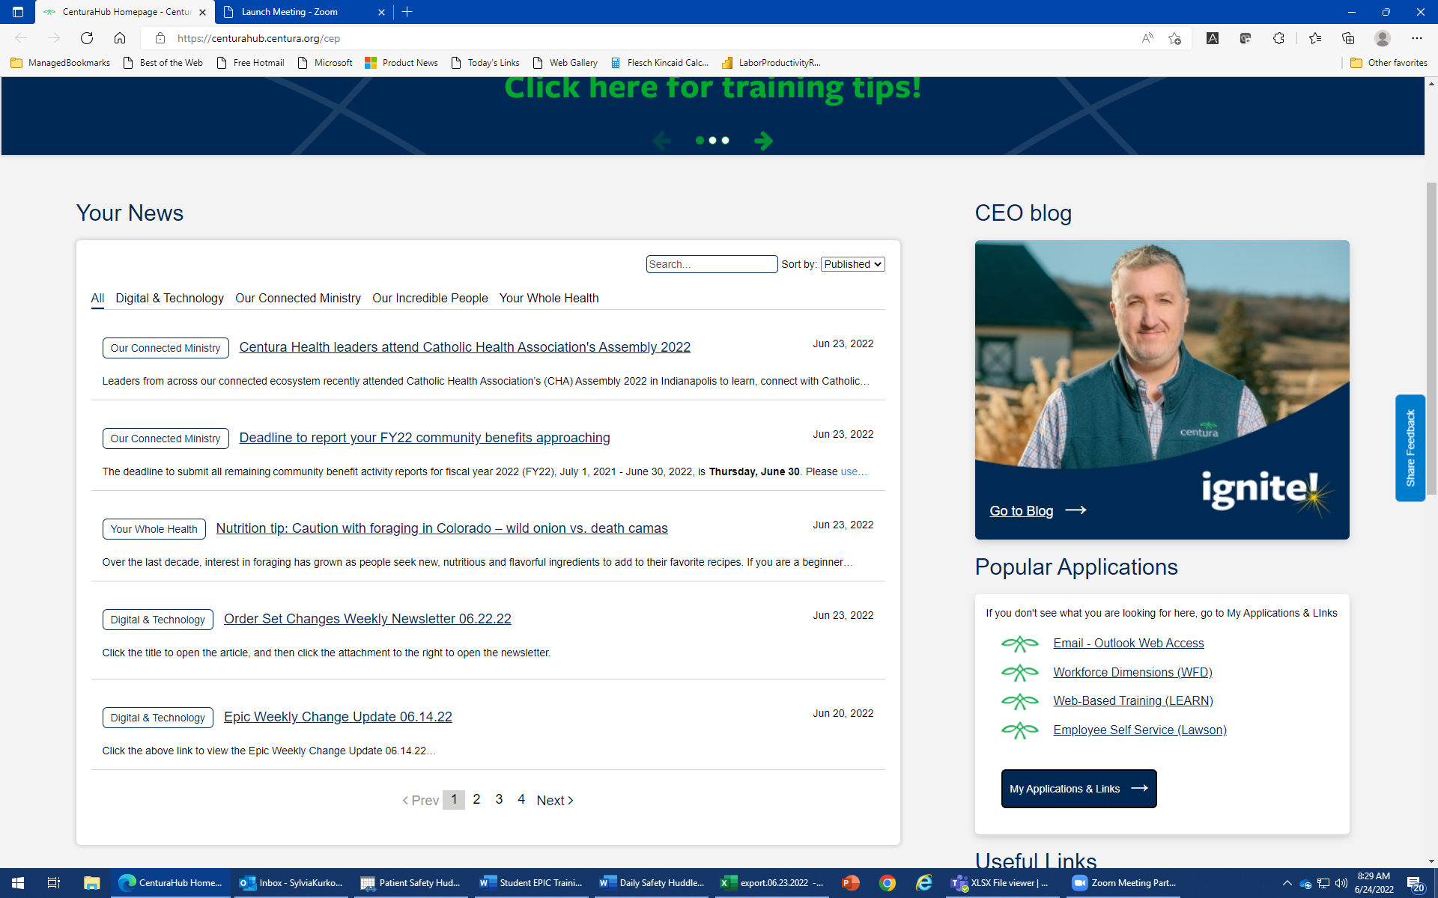

From Apps tab, search for LEARN or Academy and select or save as a Favorite

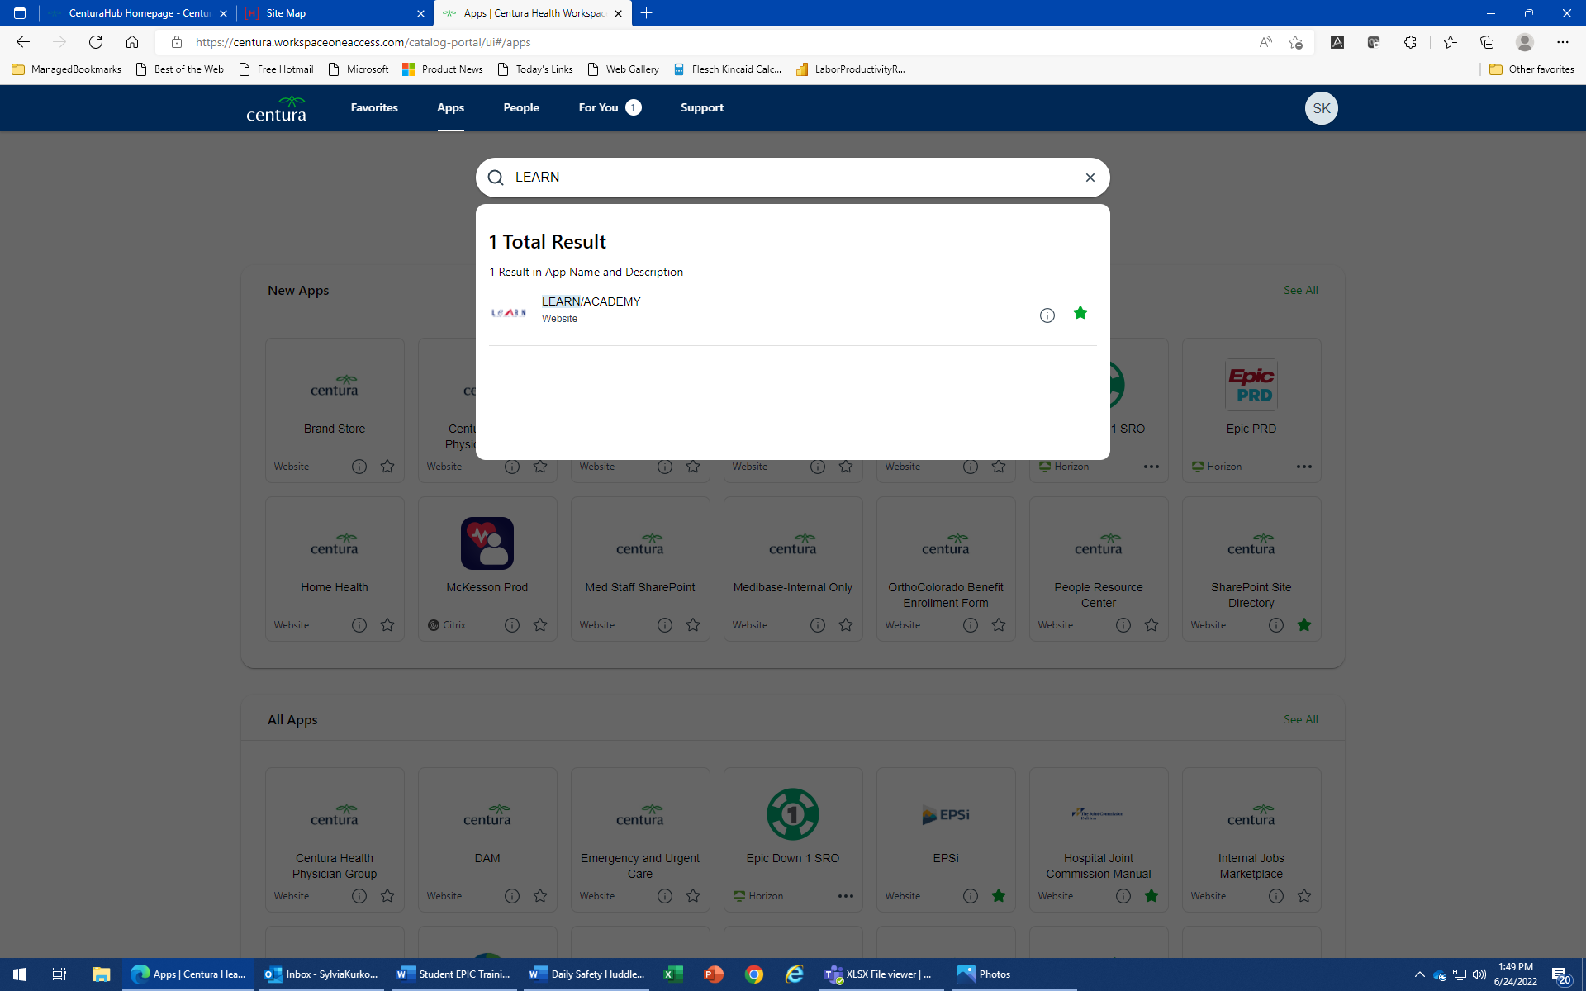

1. You will now be logged in to LEARN/Academy.
2. You will notice your name on top right hand side
3. The default view will be your **To Do List**
4. You will notice that the title of your required Epic Class has been displayed
5. All required Epic eLearning Classes will already be assigned to you

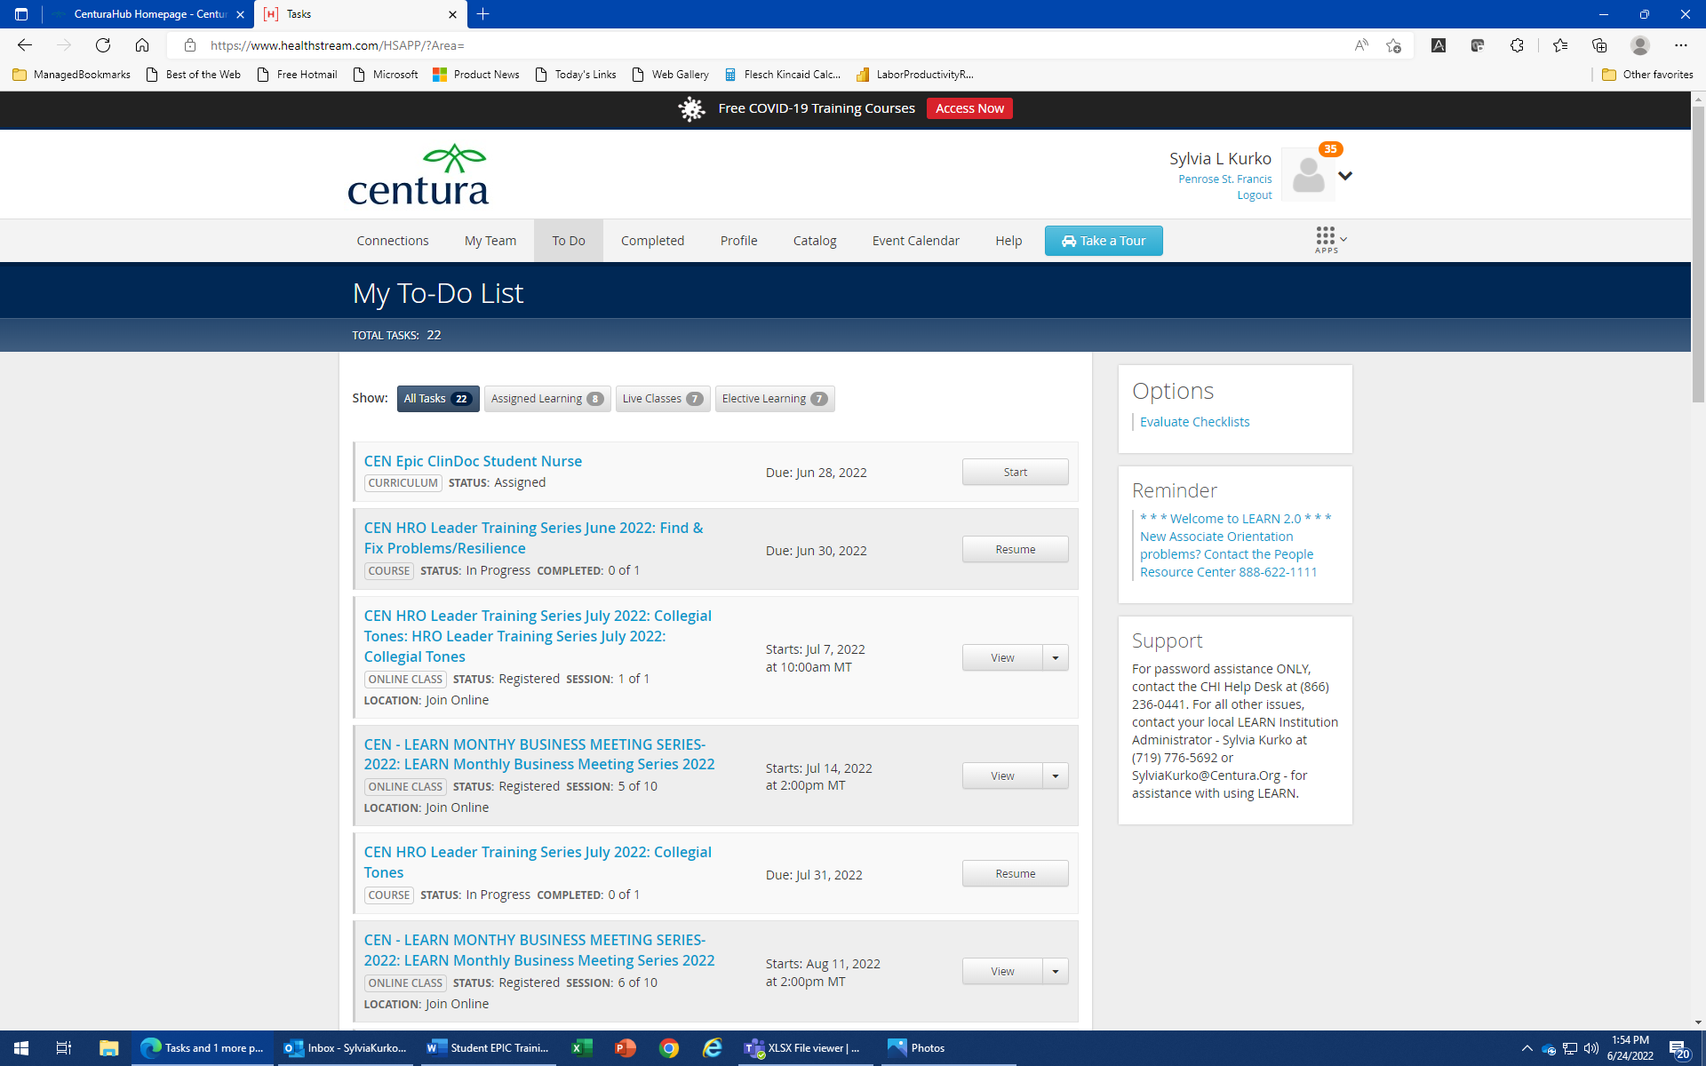

1. Begin by clicking on “Start” to view your assigned eLearning classes. If you leave and come back to the task, you will see “Resume” instead of “Start”
2. Complete each module within the course. The final module is the EUPA (End User Proficiency Assessment)

