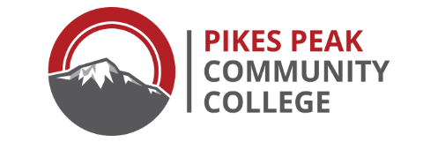

Pikes Peak Community College - Institutional Review Board

EXEMPT PROTOCOL

The principal investigator/project director is authorized to make the first determination of eligibility for exemption; however, the College bears the responsibility for concurring in that determination based on notice provided by the principal investigator to the Institutional Review Board.

The following exemptions do NOT apply when (a) deception of subjects may be an element of the research; (b) subjects are under the age of eighteen; (c) the activity may expose the subject to discomfort or harassment beyond levels encountered in daily life; or (d) fetuses, pregnant women, human in vitro fertilization, children, or individuals involuntarily confined or detained in penal institutions are subjects of the activity.

EXCEPT FOR THE ABOVE EXCLUSIONS, the federally-approved Categories of Exemption are:

- Research conducted in established or commonly accepted educational settings involving normal educational practices, such as: (a) research on regular and special education instructional strategies; (b) research on the effectiveness of or the comparison among instructional techniques curricula, or classroom management methods.

- Research involving the use of educational tests (cognitive, diagnostic, aptitude, achievement), survey procedures, interview procedures or observation of public behavior, unless: (a) information obtained is recorded in such a manner that human subjects can be identified, directly or through identifiers linked to the subjects; and (b) any disclosure of the human subjects’ responses outside the research reasonably place the subjects at risk of criminal or civil liability or be damaging to the subjects’ financial standing, employability, or reputation.

- Research involving the use of educational tests (cognitive, diagnostic, aptitude, or achievement), survey procedures, interview procedures, or observation of public behavior that is not exempt under Category 2 if: (a) the human subjects are elected or appointed public officials, or candidates for public office, or (b) federal statute(s) require(s) without exception that the confidentiality of the personally identifiable information will be maintained throughout the research and thereafter.

- Research involving the collection or study of existing data, documents, records, pathological specimens, or diagnostic specimens, if these sources are publicly available or if the information is recorded by the investigator in such a manner that subjects cannot be identified directly or through identifiers linked to the subjects.

- Research and demonstration projects which are conducted by or subject to the approval of department or agency heads, and which are designed to study, evaluate, or otherwise examine: (a) public benefit or service programs; (b) procedures for obtaining benefits or services under those programs; (c) possible changes in or alternatives to those programs or procedures; or (d) possible changes in methods or levels of payment for benefits or services under those programs.

- Taste and food quality evaluation and consumer acceptance studies: (a) if wholesome foods without additives are consumed, or (b) if a food is consumed that contains a food ingredient or at or below the level and for a use found to be safe, or agricultural chemical or environmental contaminant at or below the level found to be safe by the U.S. Food and Drug Administration or approved by the U.S. Environmental Protection Agency or the Food Safety and Inspection Service of the U.S. Department of Agriculture.

Exempting an activity from review does not absolve the investigator(s) of the activity from ensuring that the welfare of subjects in the activity is protected and that methods used and information provided to gain subject consent are appropriate to the activity.

Questions about whether a research activity may be exempt from human subjects review can be directed to the Chair of the PPCC Institutional Review Board (719-502-2037).

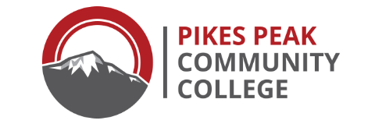
Pikes Peak Community College
Institutional Review Board

Exempt Protocol Summary Form

Title of Research Project

Principal Investigator/Project Director Department Phone Number Email address

Co-investigator/Student Investigator Department Phone Number Email address

Co-investigator/Student Investigator Department Phone Number Email address

Anticipated Funding Source:

Projected Duration of Research: |  | months | Projected Starting Date:

Other organizations and/or agencies, if any, involved in the study:

Exempt under code (see definitions on page one – check one) 1 2 3 4 5 6

SUMMARY ABSTRACT:
- What is the purpose of the study? (state the research questions and hypotheses)
- Who will be the research subjects? How will they be solicited or contacted? How many subjects will be studied? How will consent be obtained (or assent and parent consent if minors are recruited as participants)?
- What procedures will be used for data collection? What measures or observations will be taken in the study? How much time will be required of each subject?
- What methods will be used to ensure the confidentiality of the data (address the specific location of the physical storage of the data, who will have access to it, how long it will be kept, and how it will be disposed of)
- What are your plans for publication or dissemination of the results?

Attach copy of the Informed Consent Form; any questionnaires, tests or other instruments that will be used to collect data; and any recruitment materials that will be used to contact or solicit participants.
RESPONSIBILITIES OF THE PRINCIPAL INVESTIGATOR:
- Any additions or changes in procedures in the protocol will be submitted to the IRB for written approval prior to these changes being implemented.
- Any problems connected with the use of human subjects once the project has begun must be communicated to the IRB Chair.
- The principal investigator is responsible for retaining informed consent documents for a period of three years after the project.

I certify that the protocol and method of obtaining informed consent (if applicable) as approved by the PPCC Institutional Review Board will be followed during the period covered by this research project. Any future changes to the research project will be submitted to the IRB for review and approval prior to implementation.

Principal Investigator Signature: ________________________________ Date: ______/______/______

Co-Investigator/Student Signature (if appropriate): _________________________ Date: ______/______/______

Signature of IRB Committee Chair: ______________________________ Date: ______/______/______

IRB #

IRB Chair, Check 1 box:

Approved

Approved with Conditions

Refer to Full Committee Review

Informational script

By definition, “exempt” research is exempt from the requirement for a signed consent form. Nevertheless, the ethical principles listed in the Belmont Report, particularly the discussion of the first principle, respect for persons, emphasizes the importance of ensuring that subjects are fully informed about the nature of the research project so that they can make an informed decision to participate or not. An “informational script,” provides that kind of information. This material was written so that it could be attached to a questionnaire that is distributed to a classroom of students. Phone scripts, introductory letters, or face-to-face scripts should be modified as needed (adopted from the University of Pittsburg IRB).

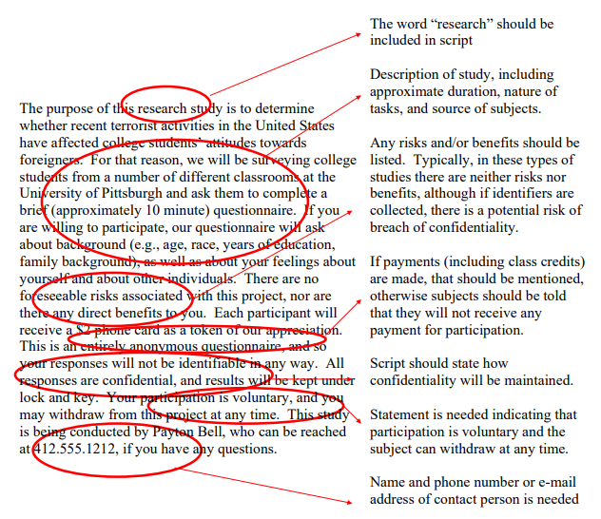

Pikes Peak Community College
Institutional Review Board

ELEMENTS OF INFORMED CONSENT

For some exempt studies, researchers may be asked to obtain the signed informed consent of participants. For those less than 18 years of age, the researcher must obtain the signed informed consent of parents or legal guardian and all reasonable attempts must be made to obtain each participant's assent, which is defined as the participant's agreement to participate in the study.

The informed consent must include the following in sequential order and in language that the participants can understand:

1. Statement of purpose of the study.

2. Short description of methodology and duration of participant involvement.

3. Statement of risks/benefits to the participants.

4. Statement of data confidentiality.

5. Statement regarding the right of the participant to withdraw from the study at any time
without negative consequences.

6. An offer to answer any questions the participant may have.

7. Contact information of all Principal Investigators, and also contact information for PPCC’s
Institutional Review Board (719-502-2037).

8. Line for signature of participants and/or parents or legal guardian except for questionnaire
research in which return of questionnaire gives implied consent.

9. Statement that participant is 18 years of age or older unless parent or legal guardian has
given consent.

In situations where participants will be deceived, items 1 and 2 are omitted and participants are told (on the signed form) that disclosure of the purpose and/or methodology could bias the outcome of the study. In this case, after the study is complete, each participant must be presented with a description of the purpose and methodology as carried out and this document must be signed by the participants "after the fact" in order to guarantee informed consent.

SAMPLE INFORMED CONSENT
The following suggestions are offered as guidelines. The exact language is the decision of the researcher.

Dear (student, parent, sir, madam, etc.):

We are conducting a study to determine _______________________. In this study, you (your child) will be asked to _____________________________. Your participation should take about _______ minutes.

There are no risks to you (your child/ward). or The only risks to you (your child) include _____________________________________.

There are no direct benefits to you for participating in this research study. However, the study may help … or There may not be any benefit for you but your participation is likely to help us find the answer to the research question. or In participating in this research, you will help contribute to the body of knowledge ….

All information will be handled in a strictly confidential manner, so that no one will be able to identify you (your child) when the results are recorded/reported.

Your (your child's) participation in this study is totally voluntary and you may withdraw at any time without negative consequences. If you wish to withdraw at any time during the study, simply _________________________________.

Please feel free to contact ______________________ (names(s), title(s) of principal researchers) at _________ phone) if you have any questions about the study. Or, for other questions, contact the Chair of the Institutional Review Board (719-502-2037).

If the participant is of age (18 years old or older), use:
I understand the study described above and have been given a copy of the description as outlined above. I am 18 years of age or older and I agree to participate.
________________________________
Signature of Participant Date
If the participant is not of age, use:
I understand the study described above and have been given a copy of the description as outlined above. I agree to allow my child to participate with his/her assent when possible.

_________________________________
Signature of Parent/Guardian Date
ASSENT format:
I understand what I must do in this study and I want to take part in the study.

_________________________________
Signature of Child Date

