How to Make an Appointment Using RegisterBlast
Students Instructions

- Select a Testing Center Campus to take your test.
PPSC student schedule here for the Centennial Campus
PPSC students schedule here for the Rampart Range Campus

- Select a group from the drop-down menu. Choose: PPSC Academic Testing Spring 2023.
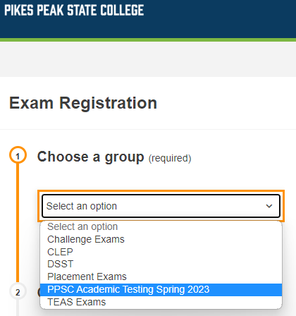
- Choose your exam. If you are taking MAT 1340 Block 1 test for Professor Jim Bond, the exam name will show in the following format: MAT 1340_Block 1 Test_JBond.
Note: Appointments are available after your instructor has submitted your exam. Contact your instructor if your exam is not listed under this step.

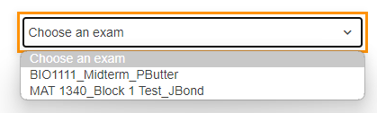
- Click the Choose a Date For Your Exam field to choose an available testing date from the calendar.
  - Available dates will show on bold.
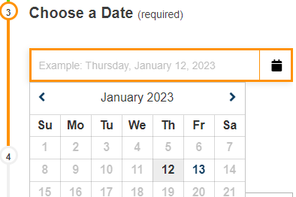

- Click the Choose a Time field to select an available testing time.
  - Exams are stopped and collected 15 minutes prior to closing. We close at 5pm.
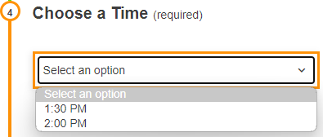
- Enter the test taker information
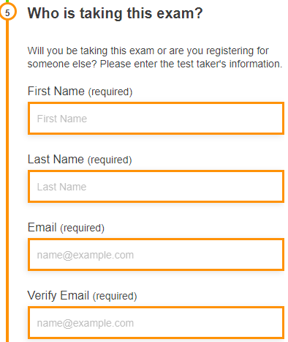
- Read and agree to the Exam guideline acknowledgement.
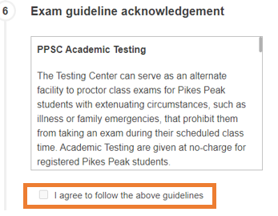
- Under Needed information, enter your phone number and your PPSC student number.

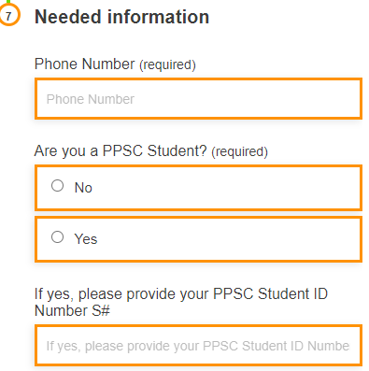

- Click Add to Cart.
- If you need to schedule another exam, click Add Another Exam, and repeat the previous process. Otherwise, review your exam(s) information and click Complete Registration.
  - Although it shows an amount, class/make-up test are offered free of charge for Pikes Peak students.

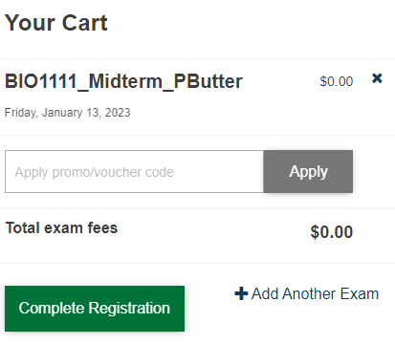

- Upon a successful exam registration, you will receive an immediate email confirmation receipt.
  - You do not have to print the receipt.
- You are allowed to check-in for your exam 30 minutes before your scheduled exam appointment time.

