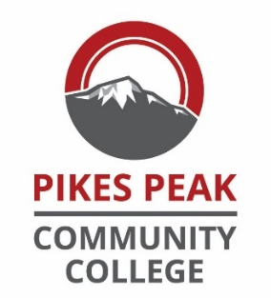

Master Course Syllabus

Course Name and Number (without section number)

Purpose of Document
This document contains important information about this course’s objectives. It may be helpful for you to retain a copy for your records, along with the class specific syllabus. This document will be especially helpful if you decide to later change your course of study.
Pikes Peak Community College and the Colorado Department of Higher Education have determined that graduates should have a broad range of learning skills as well as discipline related skills. Both types of skills are detailed below.

Course Description
Insert CCNS info here
Credit Hours & Contact Hours

Course Learning Outcomes
Insert CCNS info here

Topical Outline
Insert CCNS info here

Certification Information or similar information
If applicable, insert here. If not, delete.

