

**Intern & Volunteer Opportunities**

**Discover Goodwill**

* + **Possibilities Program:** A one-of-a-kind program teaching individuals with developmental and learning challenges core life skills in a unique town square environment.
    - **Apartment Specialist** **–** Teach participants to live more independently and actively in the home—including basic cooking, household management and grocery shopping in Possibilities’ fully-functional kitchen.
    - **Art Specialist –** Share your passion for art using a variety of mediums—such as jewelry making, sewing/quilting, leatherwork and scrapbooking.
    - **Chaperone –** Help participants actively engage in the community by accompanying them on tours, special events and other civic-focused activities.
    - **Classroom Aid and Tutor –** Work one-on-one and in small groups using multi-sensory curriculum and activities to reinforce reading, writing and math skills.
    - **Computer Lab Assistant** – Share your computer skills to help participants learn basic computer competencies using interactive and research-based programs.
    - **Community Center** – Facilitate group activities with participants to encourage new interests, build friendships and develop interpersonal skills with peers.
    - **Credit Union Teller** –Help participants discover the magical and practical applications of numbers by creating and managing a personal budget, opening a bank account and using a debit card.
    - **Fitness Center Specialist –** Lead fitness classes in exercise, yoga, dance, music and martial arts. Assist participants with the utilization of adaptive gym equipment. Help educate participants about the benefits of healthy eating.
    - **Gardener –** Show off your “green thumb” by helping participants plant, care for and harvest vegetables and flowers in our beautiful, walk-out garden.
    - 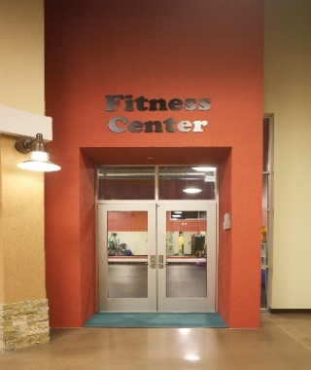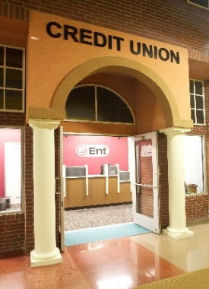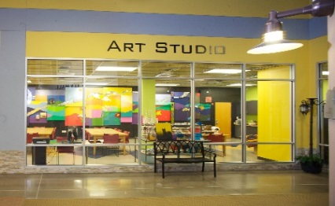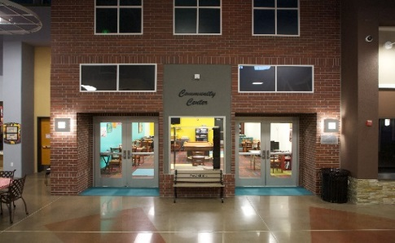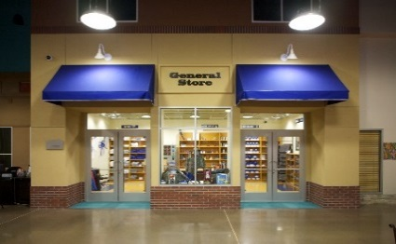**General Store –** Help participants become smart consumers—including making change, money counting, budgeting and purchasing goods on a cashless system.
  + **Voyages:** A specialized adult day program providing life engagement, socialization and community integration activities to seniors with health and age-related challenges.
    - Assist staff with recreational group activities, one-on-one interaction and engagement with clients, chaperone outings in the community, distribute meals and provide front desk support as needed.
  + **Journeys:** A specialized day program for individuals with significant disabilities.
* Assist staff with one-on-one recreational activities and engagement with clients
  + **Administrative/Clerical Support:** Provide general assistance to administrative offices: HR, Transportation/Contracts, Volunteer Services.
  + **Special Events:** Assist with fund raising events and special projects benefitting Discover Goodwill’s programs and services.
  + **Retail Centers:** 
    - **Assist with daily operations:**
      * Receive and sort donations
      * Stock merchandise
      * Assist customers with loading and unloading of merchandise
      * Help in women’s/men’s dressing rooms
    - **Assist with Super Saturday Activities every Saturday in January, April, July, and October:**
      * Greeters, Sign Spinners, Fitting Room Attendants, Merchandise Stockers, Donation Sorters, Assist with raffle drawings and hand out balloons.

**BENEFITS OF VOLUNTEERING:**

* Build your resume and network
* Explore new career options
* Learn new skills
* Connect with your community
* Make a difference in someone’s life

**REQUIREMENTS:**

* Interns/Volunteers must be 16 years of age for Retail and 18 years of age for Programs
* Must complete Volunteer Application at:

<https://www.discovermygoodwill.org/get-involved/volunteer/>

* Contact Volunteer Services to schedule interview

**CONTACT: Grace Vigil, Volunteer Services Manager**

**Email: gvigil@discovermygoodwill.org**

**Phone: (719)785-9229**

**1460 Garden of the Gods Rd., Colorado Springs, CO 80907**

**DiscoverMyGoodwill.org**

**Our Mission: *Discover Goodwill of Southern and Western Colorado is dedicated to helping people reach their highest level of personal and economic independence.***